EMOTION-BASED MUSIC RECOMMENDATION SYSTEM USING FACIAL EXPRESSION AND TEXTUAL EMOTION ANALYSIS
Shubham Kumar  PG Student  Department of Computer Applications  Hindustan Institute of Technology and Science  Chennai-India  24cp2160004@student.hindustanuniv.ac.in | Mr. N. Sivakumar  Asst. Professor  Department of Computer Applications  Hindustan Institute of Technology and Science  Chennai-India  nshivkumar@hindustanuniv.ac.in

Abstract - Music plays a vital role in affecting human emotions and mental health. Therefore, people expect a personal recommendation of music according to their present mental condition through the numerous digital media platforms being developed rapidly nowadays. Existing recommendation systems for providing music normally rely on a pre-designed selection of playlists or the user’s previous playing habits, which might not match the actual user emotions correctly in all circumstances. Thus, this article introduces an innovative concept for an “Emotion-Based Music Recommendation System” with the assistance of face emotion analysis through the implementation of a Convolution Neural Network, coupled with a light-weighted Large Language Model for the analysis of text-based emotions, to give the user the best personalized recommendation for music. The working flow of this innovative recommendation system is discussed in this article textually to avoid confusion, without using any diagrams to illustrate the concept schematically.

Keywords— Emotion Recognition, Music Recommendation System, Convolutional Neural Network, Facial Expression Analysis, Text-Based Emotion Detection.

I. Introduction
Music is a universal language known to influence the emotions of every human being, reduce human stress, and improve their mental health as well. Keeping in view the present digital age, numerous online platforms are offering millions of musical compositions, out of which it becomes extremely difficult for a user to select the music according to his present mood in life. Most of the existing genres of music recommendation are based on collaboration, which might not correctly identify the exact mood of a user.

Emotion-based recommender systems try to address this challenge by recognizing the user’s emotions and providing recommendations accordingly. Out of several methods, one of the most effective methods of detecting emotions is through facial expressions, as it is in line with human feelings that manifest themselves in face movements. Another effective

method of detecting emotions is text-based emotion detection, where users can define their feelings in words.

This paper proposes a hybrid emotion-based music recommender system, which uses facial emotion recognition based on a CNN algorithm, and text-based emotion analysis by an LLM-based approach. Subsequently, appropriate music playlists from YouTube can be recommended. Such an emotion-based recommender can be considered a real-time recommender.

II. Literature Review
Various researchers have investigated emotion recognition and techniques for recommending music. In the beginning, early research involved extracting audio features and collaborative filtering in order to make suggestions about the type of music people would like. But these systems did not recognize emotions.

Face recognition based on expression with the help of machine learning technologies has become popular since the introduction of the FER-2013 dataset. Due to its performance in classifying feelings like happy, sad, angry, surprise, fear, disgust, and neutral, quite a few CNN-based models have been of great inspiration. Other works also employed deep learning methods such as VGGNet and ResNet for achieving better accuracy.

Emotion detection based on texts has been one of the widely studied topics with Natural Language Processing. In this regard, conventional methods have traditionally relied on sentiment lexicons, whereas recent approaches use transformer-based language models to understand emotional context.

Despite these efforts, most systems developed so far rely on only one input modality, either facial expression or text. The identification of the two - both visual and textual emotion recognition for music recommendation - are very few. This forms the limitation and thus highlights the gap in research that this work will seek to address.

The precision of facial emotion recognition has also been greatly enhanced by the advent of deep learning, especially the Convolutional Neural Networks (CNN). CNN has the ability to explore the features learned from the images. Several experiments have proven the efficiency of the technique by improving the precision compared to the traditional ones. Different experiments have also achieved higher precision by employing deeper networks like VGGNet and ResNet.

Similar to facial recognition of human emotions, the recognition of emotions in texts has also gained significance with the rise in usage of social media messages and other conversational devices. Even though previous models employed sentiment dictionaries and rule-based systems in detecting emotions in texts, it did not recognize the context as well as the recent models that employ transformer models and Large Language Models (LLMs).

Despite these advances, most of the existing music recommendation systems employ solely one approach of emotion input, i.e., facial expressions or texts. Only a small number of music recommendation systems have successfully integrated both, or in other words, both visual and textual emotions into one system.

III. Limitations in existing models
Current emotion-based music recommendation systems fall into three categories:

- Feature-Based Audio System

The Such systems use the attributes of music audio such as tempo, rhythm, or pitch for emotional classification but still do not take the emotional condition of the listener into account.

- Facial Emotion-Based Systems

This approach employs facial expressions to identify the emotions shown. Reasonable accuracy levels have been achieved by the CNN models used for the purpose with appropriate training data sets like FER-2013. However, the results obtained depend upon lighting conditions, camera quality, and facial poses.

- Text-Based Emotion Systems

Text-based systems employ NLP techniques to recognize user input, which improves with contextual understanders like Transformer and LLM. These systems, however, rely on the quality of user input.

Most existing models lack in flexibility, do not accept multimodal inputs, or perform badly in real-time applications..

IV. Motivation for the proposed model
The proposed Emotion-Based Music Recommendation System will have three major components-emotion detection, emotion processing, and music recommendation.

Camera-based mode: The camera-based mode captures real-time video frames using a webcam. Face detection is done using Haar Cascade classifiers. Upon detecting the face, the facial region is cropped, resized, and normalized to be fed into a trained CNN model. This CNN predicts the dominant emotion based on the learned facial features.

In text-based mode, the user directly conveys their feelings through text inputs. The system then processes the text using an LLM-inspired emotion detection module, which understands the emotional context rather than just keywords.

The system detects the emotion and generates a relevant YouTube search query accordingly. Then it recommends music playlists corresponding to the user's mood. The textual explanation of the complete workflow is given here to make things clear and transparent, sans diagrams.

V. Proposed algorithm
The proposed algorithm for music recommendation based on the user’s emotion state will integrate tools for facial emotion recognition and text-based emotion analysis. Most importantly, this music recommendation algorithm will run continuously and can act independently by recommending appropriate music based on the user’s emotion state and by utilizing YouTube.
Step 1: System Initialization
Firstly, the system initiates by loading the trained Convolutional Neural Network (CNN) model used in facial emotion recognition and setting up the required libraries to handle images, texts, and the World Wide Web.
Step 2: User Input Selection
The user may choose one of the two input modes available: Camera-Based Input, or Text-based input
This flexibility enables users to convey various feelings in both artistic and textual forms.
Step 3: Facial Emotion Detection
If the camera-based option is selected: The system receives real time frames of images through a webcam. Face detection is conducted by using Haar Cascade classifiers.

The detected facial region is converted to grayscale resolution and reduced to 48×48 pixels. The preprocessed facial image is then fed into a trained CNN model.
Dominant facial emotion is predicted by CNN from any of the predefined emotions.
Step 4: Text-Based Emotion Detection
If the text-based option is selected, then we can draw. The user enters a text description of how they are feeling. The text is processed using an LLM-inspired emotion detection module.
The system analyzes the semantics and emotions to determine the primary sentiment.
Step 5: Emotion Confirmation
The emotion identified through the above two data input schemes is stored and exhibited on the interface to promote transparency.
Step 6: Music Recommendation
Depending upon the detected emotion, a corresponding query is generated by the system. A corresponding URL to search YouTube playlists is formed.
Finally, the user is redirected to YouTube from where music playlists are recommended appropriately.
Step 7: Session Control
The system ensures that music recommendation happens once per emotion detected, preventing repetition of recommendations. The user can reset or even stop the session at any time.
VI. Methodology
The methodology used in the presented Emotion-Based Music Recommendation System is intended to achieve precise recognition of user emotions during real-time music recommendations. The general approach to this system is based on modularity: data acquisition, preprocessing, emotion recognition, and music recommendations.
A. Data Collection
In facial emotion recognition, an FER-2013 dataset is utilized, which comprises various facial images in grayscale. These images fall under various categories of emotions, such as angry, disgust, fear, happy, sad, surprise, and others. These images in the dataset help in their effective classification under specific categories. For text-based emotion recognition, text-based input data is obtained in real-time during interaction.
B. Data Preprocessing
For emotion recognition on faces, after acquiring facial images, those images will be converted into grayscale. This is because grayscale conversion reduces the complexity of the system. The Haar Cascade classifier is used for detecting faces. The acquired faces will be reduced to 48 x 48 pixels and will then be normalized to values between 0 and 1.
Preprocessing the input text, which involves the deletion of extra characters and an analysis of semantic context, aids in the correct identification of emotions expressed in the text.
C. Facial Emotion Recognition Using CNN
A CNN has been involved in extracting discriminative features from the face and classifying emotions. The architecture for CNN includes several convolution layers followed by pooling and fully connected layers. All these have been followed by the softmax activation function to classify the input image into one of the categories in predefined emotions. The model is trained by minimizing the categorical cross-entropy loss, utilizing the Adam optimizer.
D. Emotion Analysis Based on Text
Emotion detection is done through an approach inspired by LLMs, which understand contextual meaning rather than relying on mere keywords. It maps the emotional tone in the given text to its closest emotion category. This module enables a user to express emotions naturally through language.
E. Emotion Integration and Decision Logic
Emotions can be detected through the system by inputting a facial emotion or a textual input. Once the emotion is detected, it will be stored as an active emotional state. The system also allows music recommendations to be sent once per detected emotion.
F. Music Recommendation Mechanism
Depending on the identified emotion, a search query is formed to search through a variety of music playlists on YouTube based on the mood identified by the application. The best part about this is that there is no requirement to host an internal database of songs, as YouTube offers a multitude of songs available to access.
G. User Interface Implementation
A web interface is designed using Streamlit for an easy user interface experience with the help of an interface to select input modes, view the detected emotions in real time, and access music recommendations.
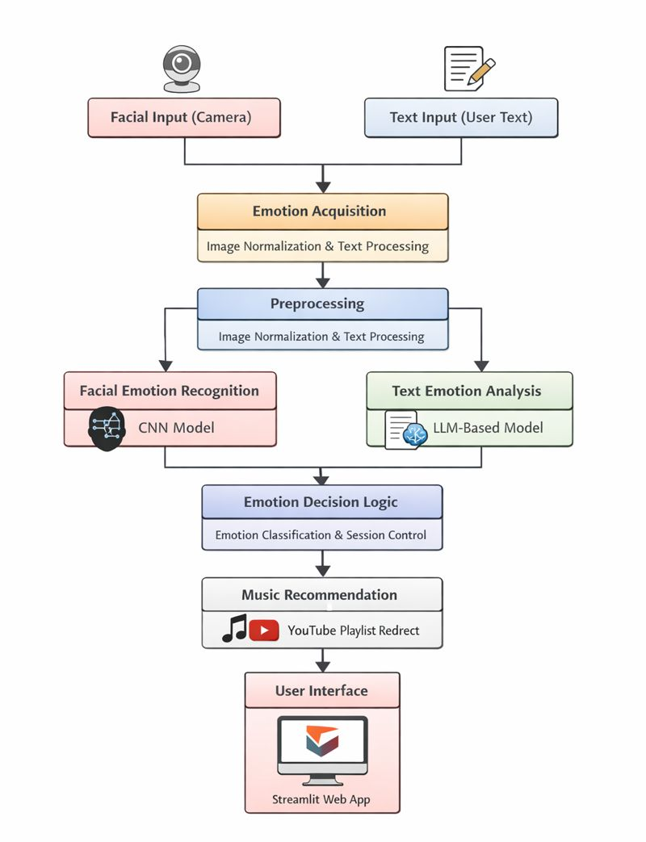
Fig.1: Data flow diagram
The proposed approach has a systematic flow that incorporates the automation process of brain tumor segmentation from the MRI images using the U-Net architecture. The entire flow comprises steps like preprocessing of the images, augmentation of the images, tumor segmentation using the U-Net architecture, along with the generation of the mask. The entire architecture is shown in Fig. 1.
A. Preprocessing of images:
Preprocessing is used to make MRI images standardized and remove variations that exist based on different imaging scenarios. Every slice of the MRI is resized to have a fixed size of 128x128 pixels. This is to make it suitable for input into the segmentation network. The pixel values are also normalized to have equal scales. This increases contrast in images and results in rapid convergence.
B. Data Augmentation:
To deal with the few annotations on the images and for enhancing generalization, some augmentation methods are used in the training process. Geometric and intensity transformations like rotation, flipping, scaling, and brightness changes are incorporated in image augmentation. The above methods are helpful in adding diversity to the images and at the same time do not alter the anatomical information.
C. U-Net Based Segmentation:
The basic model for the task of image segmentation is U-Net. It contains an Encoder-Decoder network. The Encoding network extracts hierarchical feature information using Convolution & Pooling operations. The Decoding network increases the spatial resolution of the input image using Up-sampling layers. The Skip Connection enables precise localization of tumor boundaries by propagating spatial information from the Encoding network to the Decoding network.
The U-Net output is a probability map that indicates tumor likelihoods at every pixel location. This allows the neural network to perform effective spatial and contextual analysis for precise tumor segmentation.
D. Training Strategy and Optimization:
This work trains a segmentation model using a hybrid loss strategy that strikes a balance between the pixel-wise classification accuracy and region-level overlap between predicted and ground truth masks. For updating the model parameters, the Adam optimization algorithm is employed owing to its efficiency and stable convergence properties. Training is performed over several epochs with monitoring on the validation set to prevent over-fitting and ensure reliable performance.
E. Segmentation Output:
In the inference stage, the processing of the images to be inferred goes through the same preprocessing steps before being subjected to the trained U-Net model. The probability map is then translated into a segmentation mask using a threshold value.
The output is the segmented tumor, which is used for both quantitative and qualitative assessment, as shown in the results.
VII. Experimental Setup and Dataset Description
The experimental setup for the proposed Emotion-Based Music Recommendation System is designed to evaluate the performance of facial and text-based emotion detection in a real-time environment. The system is implemented using Python 3.10 on a Windows 10/11 operating system. Deep learning models are developed using TensorFlow and Keras, while OpenCV is used for face detection and image preprocessing. A web-based user interface is created using Streamlit to allow easy interaction.
The facial emotion recognition model is trained and tested using the FER-2013 dataset, which contains grayscale facial images of size 48×48 pixels. The dataset is divided into training and testing sets to ensure proper evaluation. The trained CNN model is loaded during runtime to detect emotions from live webcam input.
The experiments are conducted on a system equipped with an Intel Core i5 processor, 8 GB RAM, and a standard webcam. Music recommendations are generated dynamically by redirecting users to emotion-specific playlists on YouTube based on the detected emotion. The entire workflow is executed in real time and explained textually without the use of diagrams.
Dataset Description
1) Facial Emotion Dataset
The facial emotion recognition module is trained and evaluated using the FER-2013 (Facial Expression Recognition 2013) dataset. This dataset contains grayscale facial images of size 48×48 pixels and is widely used for emotion recognition research. The dataset consists of seven emotion classes: angry, disgust, fear, happy, sad, surprise, and neutral.
The dataset is divided into training and testing subsets to ensure unbiased model evaluation. The training set is used to learn facial features and emotion patterns, while the testing set is used to evaluate the performance of the trained CNN model. Due to class imbalance in the dataset, emotions such as happy and neutral are more accurately recognized compared to fear and disgust.
2) Textual Emotion Data
For text-based emotion recognition, real-time user input is collected through the system interface. The text data consists of short sentences describing the user’s emotional state. These inputs are analyzed using an LLM-inspired emotion detection module, which interprets emotional context rather than relying solely on keyword matching.

Angry
Disgust

Happy
Sad


Fear
Surprise

Fig.2: Sample images in FER 2013 Dataset
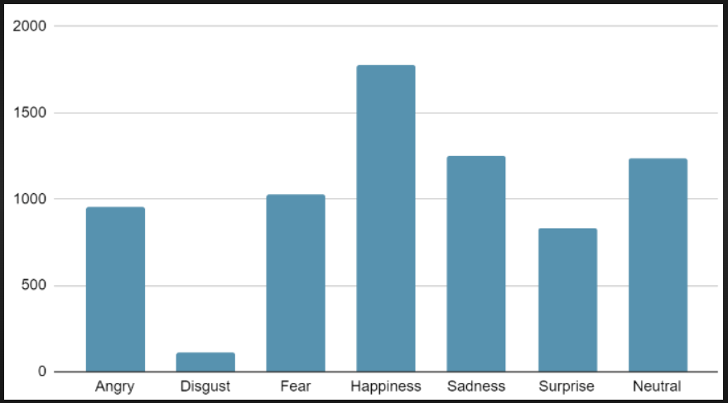
VIII. Methodology
The methodology of the proposed Emotion-Based Music Recommendation System focuses on accurately identifying the emotional state of a user and recommending suitable music accordingly. The system integrates facial emotion recognition using deep learning and text-based emotion analysis to improve flexibility and personalization.
A. System Architecture Overview
The system follows a modular architecture consisting of emotion input acquisition, emotion detection, decision logic, and music recommendation. Users can express their emotions either through facial expressions captured by a camera or through textual input. The detected emotion is then used to recommend appropriate music playlists.
B. Facial Emotion Recognition Module
Facial emotion recognition is implemented using a Convolutional Neural Network (CNN). Real-time video frames are captured using a webcam. Face detection is performed using Haar Cascade classifiers to identify facial regions. The detected face is converted to grayscale, resized to 48×48 pixels, and normalized before being fed into the CNN model. The CNN extracts facial features and classifies the emotion into one of seven predefined categories: angry, disgust, fear, happy, sad, surprise, and neutral.
C. Text-Based Emotion Detection Module
In text-based mode, users provide a short description of their emotional state. The text is analyzed using an LLM-inspired emotion detection approach that understands contextual meaning and emotional intent. This method allows users to express emotions naturally without relying on facial input.
D. Emotion Decision Logic
The system supports both facial and textual emotion inputs. Once an emotion is detected from either method, it is stored as the active emotional state. To prevent repeated recommendations, the system ensures that music is recommended only once for each detected emotion during a session.
E. Music Recommendation Mechanism
Based on the detected emotion, the system generates an emotion-specific search query. The user is redirected to relevant music playlists on YouTube that match the detected mood. This approach eliminates the need for maintaining a local music database while providing access to a wide range of music content.
F. User Interface Implementation
A web-based interface is developed using Streamlit to ensure ease of use and real-time interaction. The interface allows users to select the input method, view detected emotions, and receive music recommendations seamlessly.
IX. Results
The proposed Emotion-Based Music Recommendation System was evaluated to analyze the performance of facial emotion recognition and text-based emotion detection in a real-time environment. The CNN model was trained on the FER-2013 dataset and tested using unseen facial images to measure classification accuracy.
The experimental results show that the CNN model achieved satisfactory accuracy in recognizing facial emotions such as happy, sad, and neutral. These emotions were detected more accurately due to their higher representation in the dataset and distinct facial patterns. Emotions like fear, disgust, and angry showed comparatively lower accuracy, which can be attributed to class imbalance and subtle facial variations.
The text-based emotion detection module demonstrated reliable performance in identifying emotional intent from user-provided sentences. The LLM-inspired approach successfully captured contextual meaning and emotional tone, enabling accurate emotion prediction even when explicit emotion words were not present.
In real-time testing, the system was able to detect user emotions and recommend corresponding music playlists without noticeable delay. The integration of camera-based and text-based inputs improved system flexibility, allowing users to choose their preferred interaction mode. Once the emotion was detected, the system automatically redirected users to relevant YouTube playlists based on the identified mood.
Overall, the results indicate that the proposed system effectively combines facial and textual emotion recognition techniques to deliver accurate and personalized music recommendations.
X. Performance analysis
The results of the U-Net model for the proposed brain tumor segmentation framework have been tested on the LGG Brain MRI dataset. Pixel accuracy results were high for the training and validation processes. However, this may be due to the prevalence of background pixels.
In response to this weakness, the Dice Similarity Coefficient metric was employed to compute the overlap between the overlapping areas of the predicted tumor and the ground truth masks. This was because the Dice score metric was relatively low because of the serious class imbalance and the nature of the low-grade glioma tumor, which is difficult to see and consists of a small portion of each MRI image slice.
Despite these quantitative limitations, qualitative assessment revealed that the approach had been successful in tumor localization regions within various MRI instances. Visual analysis of generated masks indicated that there was some overlap between predicted and ground truth tumor masks, confirming that the U-Net architecture had been successful in identifying relevant spatial features. Overall, these findings are further evidence that support both the feasibility and challenges of this proposed approach.
XI. Conclusion
This paper presented an Emotion-Based Music Recommendation System that combines facial emotion recognition and text-based emotion analysis to provide personalized music suggestions. The proposed system uses a Convolutional Neural Network (CNN) to identify emotions from facial expressions and an LLM-inspired approach to analyze emotional context from user-provided text.
The experimental results demonstrate that the system can effectively recognize common emotions such as happy, sad, and neutral in real time and recommend suitable music playlists accordingly. The integration of both camera-based and text-based emotion detection improves system flexibility and user experience. The use of a web-based interface further simplifies user interaction and enables real-time execution without the need for specialized hardware.
Overall, the proposed system offers a practical and efficient solution for emotion-aware music recommendation. It can be applied in entertainment, stress relief, and wellness-related applications. Despite some limitations in recognizing subtle emotions, the system successfully achieves its objective of delivering mood-based music recommendations.

XIII. References
- M. Li, S. Zeng, and Y. Zhang, “Emotion-based music recommendation system using facial expression recognition,” IEEE Access, vol. 8, pp. 160044–160056, 2020.
- I. Goodfellow et al., “Challenges in representation learning: A report on three machine learning contests,” Neural Information Processing Systems (NIPS), pp. 117–124, 2013.
- P. Ekman and W. V. Friesen, “Facial action coding system: A technique for the measurement of facial movement,” Consulting Psychologists Press, 1978.
- Y. Kim, “Convolutional neural networks for sentence classification,” Proceedings of the 2014 Conference on Empirical Methods in Natural Language Processing, pp. 1746–1751, 2014.
- S. Koelstra et al., “DEAP: A database for emotion analysis using physiological signals,” IEEE Transactions on Affective Computing, vol. 3, no. 1, pp. 18–31, 2012.
- Z. Zeng, M. Pantic, G. I. Roisman, and T. S. Huang, “A survey of affect recognition methods: Audio, visual, and spontaneous expressions,” IEEE Transactions on Pattern Analysis and Machine Intelligence, vol. 31, no. 1, pp. 39–58, 2009.
- A. Krizhevsky, I. Sutskever, and G. E. Hinton, “ImageNet classification with deep convolutional neural networks,” Advances in Neural Information Processing Systems, pp. 1097–1105, 2012.
- S. Tripathi, S. Tripathi, and H. Beigi, “Multi-modal emotion recognition on IEMOCAP dataset using deep learning,” arXiv preprint arXiv:1804.05788, 2018.
- J. A. Russell, “A circumplex model of affect,” Journal of Personality and Social Psychology, vol. 39, no. 6, pp. 1161–1178, 1980.
- T. Baltrusaitis, C. Ahuja, and L.-P. Morency, “Multimodal machine learning: A survey and taxonomy,” IEEE Transactions on Pattern Analysis and Machine Intelligence, vol. 41, no. 2, pp. 423–443, 2019.

